**Assignment 1**

**Date- 16.07.2020.**

**---------------------------------------------------------------------**

1. **Create Database -** 
   1. create database assignment_1;
   2. show database;

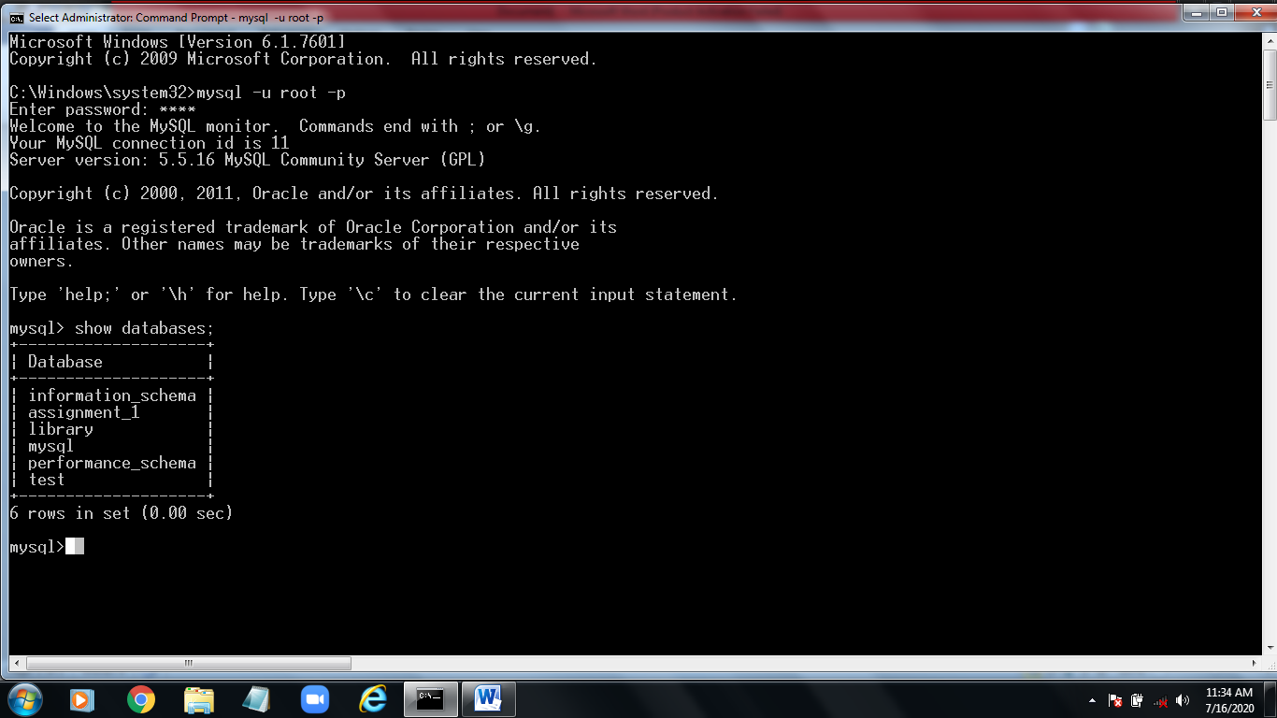

**Create table – customers.**

1. create table customers

(

Cnum int(4),

Cname varchar(10),

City varchar(10),

Rating int(4),

Snum int(4)

);

***Insert data into table --> bellow formate add all data.***

insert into customers

values(

2001,’Hoffman’,’London’,100,1001

);

**Create table – order.**

1. create table order

(

Onum int(4),

Amt float(7,2),

Odate date,

Cnum int(4),

Snum int(4)

);

***Insert data into table --> bellow formate add all data.***

insert into order

values(

3001,18.69,’1990-10-03’,2008,1007

);

**Create table – salespeople.**

1. create table salespeople

(

Snum int(4),

Sname varchar(10),

City varchar(10),

Comm float(3,2)

);

***Insert data into table --> bellow formate add all data.***

insert into salespeople

values(

1001,’Peel’,’London’,0.12

);

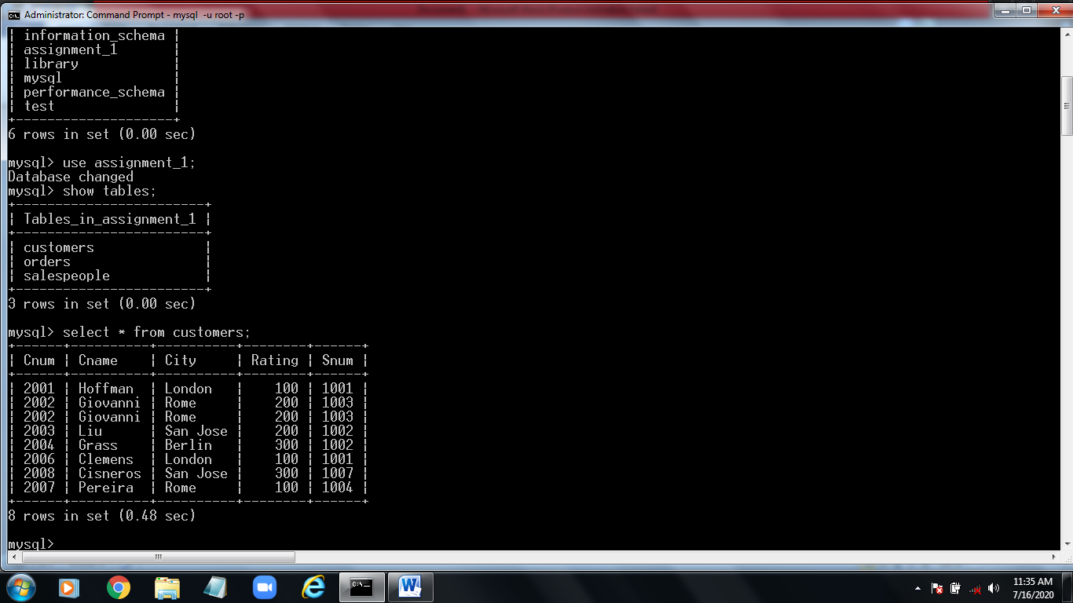

**Show the tables -**

* + 1. Select * from customers.
    2. Select * from orders.
    3. Select * from salespeople.

